|  |  |
| --- | --- |
| THe ART Gallery TRACKING SYSTEM Consulting PrOJECT REPORT  December 4, 2019 | BYGB-7973-001: Database Management  Dr. W. “RP” Raghupathi, MBA, Ph.D, LL.M  Professor  HAWKGIRL  Annuo Qian (Alice)  Haoyan Ou (Amy)  Bao Ngoc Dinh (Jane)  Tram Ngoc Le (Jennie) |

**Art Gallery Tracking System Revised Entity-Relationship Model Diagram**

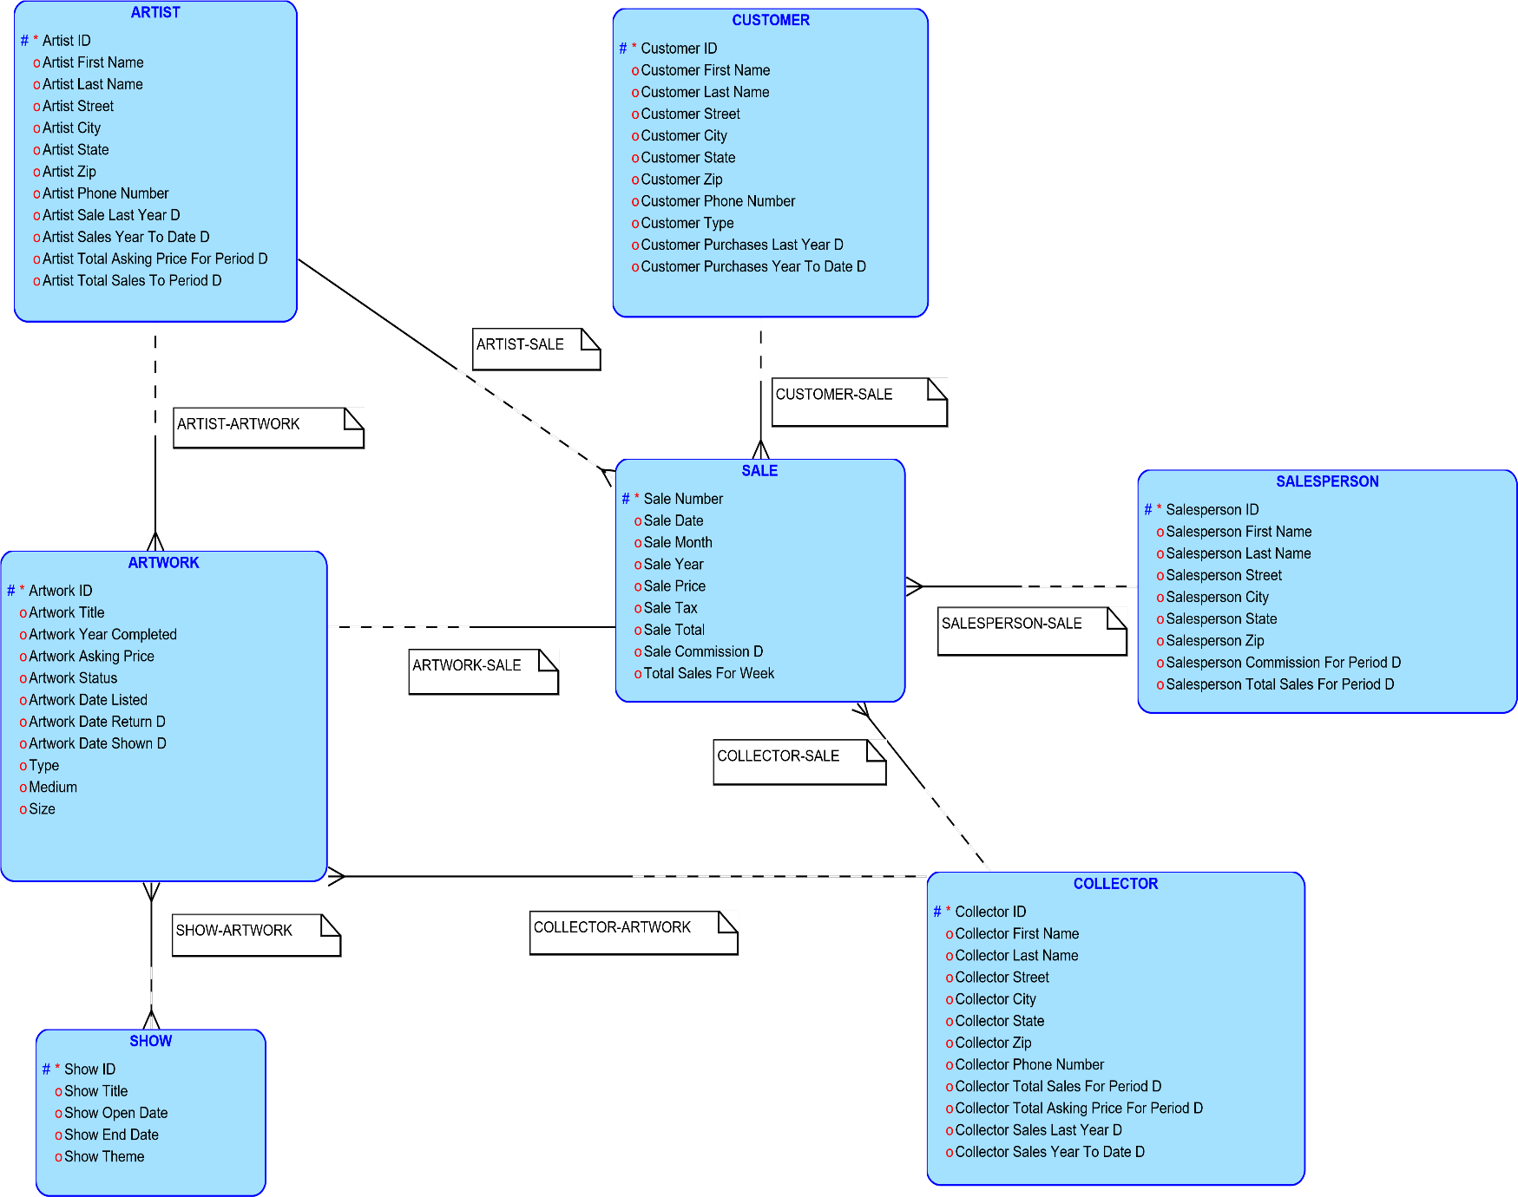

**Entity-Relationship Model Data Dictionary for Art Gallery Tracking System**

|  |  |  |  |
| --- | --- | --- | --- |
| **Entity** | **Attributes** | **Unique Identifier** | **Data Type** |
| Artist | Artist City |  | CHAR(20) |
|  | Artist First Name |  | CHAR(20) |
|  | Artist ID | Artist ID | CHAR(10) |
|  | Artist Last Name |  | CHAR(20) |
|  | Artist Phone Number |  | CHAR(12) |
|  | Artist Sales Last Year D |  | CHAR(10) |
|  | Artist Sales Year To Date D |  | CHAR(10) |
|  | Artist State |  | CHAR(2) |
|  | Artist Street |  | CHAR(20) |
|  | Artist Total Asking Price For Period D |  | CHAR(10) |
|  | Artist Total Sales To Period D |  | CHAR(10) |
|  | Artist Zip |  | CHAR(5) |
| Artwork | Artwork Asking Price |  | CHAR(10) |
|  | Artwork Date Listed |  | DATE |
|  | Artwork Date Returned D |  | DATE |
|  | Artwork Date Shown D |  | DATE |
|  | Artwork ID | Artwork ID | CHAR(10) |
|  | Artwork Status |  | CHAR(20) |
|  | Artwork Title |  | CHAR(30) |
|  | Artwork Year Completed |  | CHAR(4) |
|  | Medium |  | CHAR(20) |
|  | Size |  | CHAR(20) |
|  | Type |  | CHAR(20) |
| Collector | Collector City |  | CHAR(20) |
|  | Collector First Name |  | CHAR(20) |
|  | Collector ID | Collector ID | CHAR(10) |
|  | Collector Last Name |  | CHAR(20) |
|  | Collector Phone Number |  | CHAR(12) |
|  | Collector Sales Last Year D |  | CHAR(10) |
|  | Collector Sales Year To Date D |  | CHAR(10) |
|  | Collector State |  | CHAR(2) |
|  | Collector Street |  | CHAR(20) |
|  | Collector Total Asking Price For Period D |  | CHAR(10) |
|  | Collector Total Sales To Period D |  | CHAR(10) |
|  | Collector Zip |  | CHAR(5) |
| Customer | Customer City |  | CHAR(20) |
|  | Customer First Name |  | CHAR(20) |
|  | Customer ID | Customer ID | CHAR(10) |
|  | Customer Last Name |  | CHAR(20) |
|  | Customer Phone Number |  | CHAR(12) |
|  | Customer Purchases Last Year D |  | CHAR(10) |
|  | Customer Purchases Year To Date D |  | CHAR(10) |
|  | Customer State |  | CHAR(2) |
|  | Customer Street |  | CHAR(20) |
|  | Customer Type |  | CHAR(20) |
|  | Customer Zip |  | CHAR(5) |
| Sale | Sale Commission D |  | CHAR(10) |
|  | Sale Date |  | CHAR(2) |
|  | Sale Month |  | CHAR(3) |
|  | Sale Number | Sale Number | CHAR(10) |
|  | Sale Price |  | CHAR(10) |
|  | Sale Tax |  | CHAR(10) |
|  | Sale Total |  | CHAR(10) |
|  | Sale Year |  | CHAR(4) |
|  | Total Sales For Week |  | CHAR(10) |
| Salesperson | Salesperson City |  | CHAR(20) |
|  | Salesperson commission For Period D |  | CHAR(10) |
|  | Salesperson First Name |  | CHAR(20) |
|  | Salesperson ID | Salesperson ID | CHAR(10) |
|  | Salesperson Last Name |  | CHAR(20) |
|  | Salesperson State |  | CHAR(2) |
|  | Salesperson Street |  | CHAR(20) |
|  | Salesperson Total Sales For Period D |  | CHAR(10) |
|  | Salesperson Zip |  | CHAR(5) |
| Show | Show End Date |  | DATE |
|  | Show ID | Show ID | CHAR(10) |
|  | Show Open Date |  | DATE |
|  | Show Theme |  | CHAR(20) |
|  | Show Title |  | CHAR(30) |

**Assumptions for Art Gallery Tracking System’s Revised Entity-Relationship Model**

* Artist Sale Last Year D is a descriptive attribute between SALE and ARTIST.
* Artist Sales Year To Date D is a descriptive attribute between SALE and ARTIST.
* Artist Total Asking Price for Period D is a descriptive attribute between ARTWORK and ARTIST.
* Artist Total Sales To Period D is a descriptive attribute between SALE and ARTIST.
* Artwork Date Return D is a descriptive attribute between ARTWORK and SHOW.
* Artwork Date Shown D is a descriptive attribute between ARTWORK and SHOW.
* Collector Total Sales For Period D is the descriptive attribute between SALE and COLLECTOR
* Collector Total Asking Price For Period D is the descriptive attribute between ARTWORK and COLLECTOR
* Collector Sales Last Year D is the descriptive attribute between SALE and COLLECTOR
* Collector Sales Year To Date D is the descriptive attribute between SALE and COLLECTOR
* Customer Type can be a customer who has made a purchase or a potential customer who came to a show and filled out potential customer form.
* Customer Purchases Last Year D is the descriptive attribute between SALE and CUSTOMER
* Customer Purchases Year to Date D is the descriptive attribute between SALE and CUSTOMER
* Salesperson Commission For Period D is the descriptive attribute between SALE and SALES PERSON
* Salesperson Total Sales For Period D is the descriptive attribute between SALE and SALESPERSON
* Sale Commission D is the descriptive attribute between SALE and SALESPERSON.

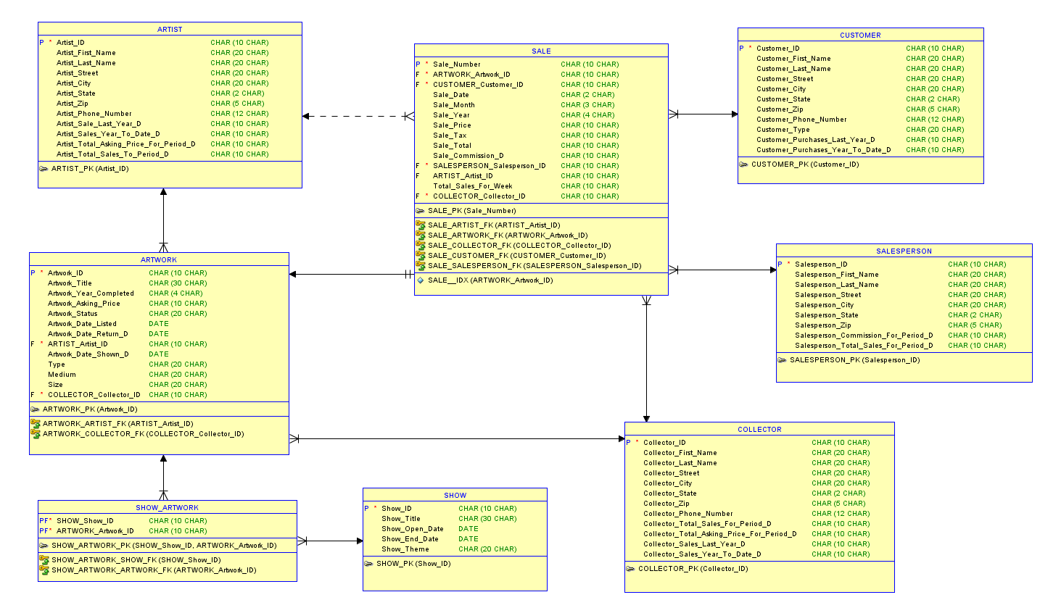**Art Gallery Tracking System Default Relational Model**

**Art Gallery Tracking System Revised Relational Model**

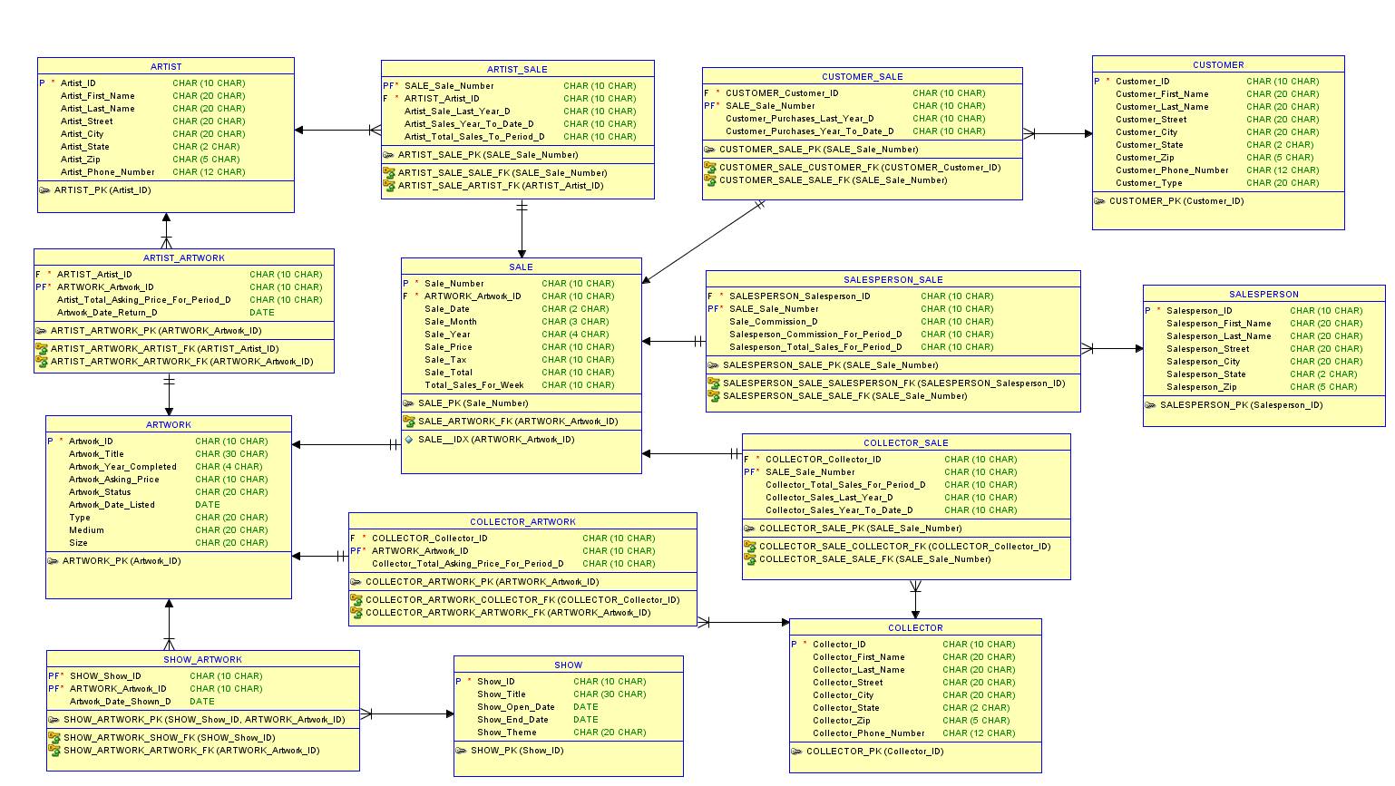

**Art Gallery Tracking System Normalized Relational Model**

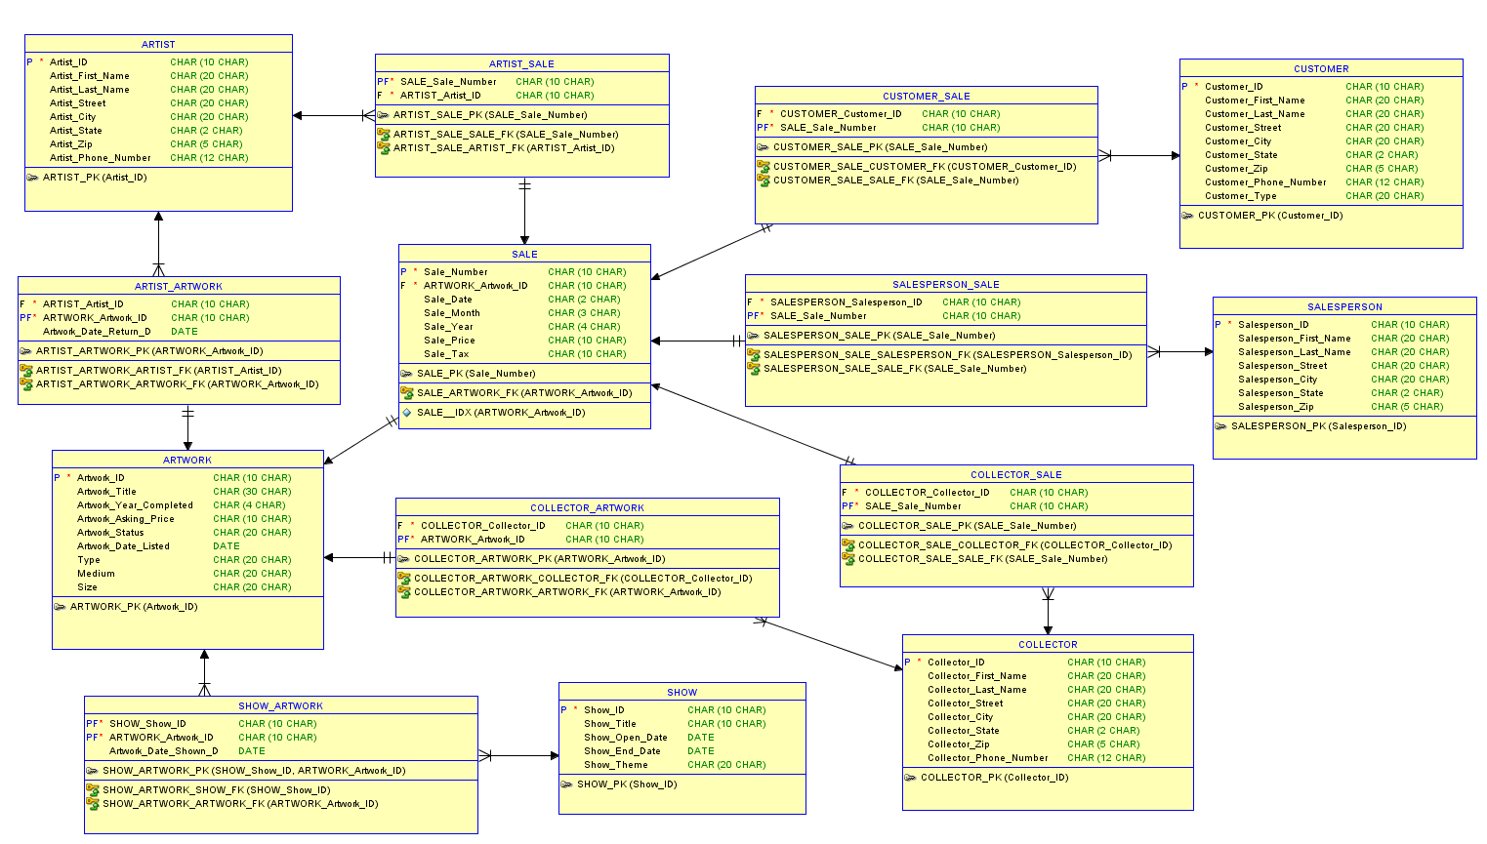

**Assumptions for Art Gallery Tracking System’s Normalized Physical Data Model**

**1NF:**

* Each artist, each customer, each salesperson, and each collector only have one known address in the system, including information about street, city, state, zip. Therefore, having the street, city, state, and zip for each entity as non-key attributes is not in violation of the 1NF.
* Each artist, each customer, and each collector only have one known phone number in the system. Therefore, having phone number for each entity as a non-key attribute is not in violation of the 1NF.
* An artwork is only listed once. Therefore, having artwork date listed as a non-key attribute is not in violation of the 1NF.
* An artwork only has one type, one medium, and one size. Therefore, having type, medium, and size as non-key attributes is not in violation of the 1 NF.
* Each show only has one theme and one title. Therefore, having show theme and show title as non-key attributes is not in violation of normal form.

**3NF calculations:**

**Artist:**

* Artist Sale Last Year D is a nested calculation = Sum{Sale Total for the respective artist last year}
* Artist Sales Year To Date D is a nested calculation = Sum{Sale Total for the respective artist year to date}
* Artist Total Asking Price for Period D = Sum{Asking Price for paintings of the respective artist in a certain period}
* Artist Total Sales To Period D is a nested calculation=Sum{Sale Total for the respective artist in a certain period}

**Sale:**

* Sale Commission is a percentage from Sale Price
* Sale Total = Sum{Sale Price, Sale Tax}
* Total Sales for Week is a nested calculated field (Sale Total): Total Sales for Week = Sum{Sale Total} for that week

**Customer:**

* Customer Purchases Last Year D is a nested calculated field (Sale Total): Customer Purchases Last Year D = Sum{Sale Total} that one customer made over last year.
* Customer Purchases Year To Date D is a nested calculated field(Sale Total):Customer Purchases Year To Date = Sum{Sale Total} that one customer made from year to date.

**Salesperson:**

* Salesperson Commision For Period D is a nested calculated field (Sale Commision D): Salesperson Commission For Period D = Sum{Sale Commission D} for the period.
* Salesperson Total Sales For Period D is a nested calculated field (Sale Total): Salesperson Total Sales for Period D   Sum {Sale Total} that the sales person made for the Period.

**Collector:**

* Collector Total Sales For Period D is a nested calculated field (Sale Total): Collector Total Sales For Period D = Sum{Sale Total} that the collector made for the period.
* Collector Total Asking Price For Period D = Sum{Artwork Asking Price} for an artwork that a collector have.
* Collector Sales Last Year D is a nested calculated field (Sale Total): Collector Sales Last Year D = Sum{Sale Total} that a collector made for last year.
* Collector Sales Year To Date D is a nested calculated field (Sale Total): Collector Sales Year To Date D =Sum{Sales Total} that a collector made year to date.

**DDL Script for Art Gallery Tracking System**

-- Generated by Oracle SQL Developer Data Modeler 19.2.0.182.1216

-- at: 2019-11-21 17:33:14 EST

-- site: Oracle Database 11g

-- type: Oracle Database 11g

CREATE TABLE artist (

artist_id CHAR(10 CHAR) NOT NULL,

artist_first_name CHAR(20 CHAR),

artist_last_name CHAR(20 CHAR),

artist_street CHAR(20 CHAR),

artist_city CHAR(20 CHAR),

artist_state CHAR(2 CHAR),

artist_zip CHAR(5 CHAR),

artist_phone_number CHAR(12 CHAR)

);

ALTER TABLE artist ADD CONSTRAINT artist_pk PRIMARY KEY ( artist_id );

CREATE TABLE artist_artwork (

artist_artist_id CHAR(10 CHAR) NOT NULL,

artwork_artwork_id CHAR(10 CHAR) NOT NULL,

artwork_date_return_d DATE

);

ALTER TABLE artist_artwork ADD CONSTRAINT artist_artwork_pk PRIMARY KEY ( artwork_artwork_id );

CREATE TABLE artist_sale (

sale_sale_number CHAR(10 CHAR) NOT NULL,

artist_artist_id CHAR(10 CHAR) NOT NULL

);

ALTER TABLE artist_sale ADD CONSTRAINT artist_sale_pk PRIMARY KEY ( sale_sale_number );

CREATE TABLE artwork (

artwork_id CHAR(10 CHAR) NOT NULL,

artwork_title CHAR(30 CHAR),

artwork_year_completed CHAR(4),

artwork_asking_price CHAR(10 CHAR),

artwork_status CHAR(20 CHAR),

artwork_date_listed DATE,

type CHAR(20 CHAR),

medium CHAR(20 CHAR),

"Size" CHAR(20 CHAR)

);

ALTER TABLE artwork ADD CONSTRAINT artwork_pk PRIMARY KEY ( artwork_id );

CREATE TABLE collector (

collector_id CHAR(10 CHAR) NOT NULL,

collector_first_name CHAR(20 CHAR),

collector_last_name CHAR(20 CHAR),

collector_street CHAR(20 CHAR),

collector_city CHAR(20 CHAR),

collector_state CHAR(2 CHAR),

collector_zip CHAR(5 CHAR),

collector_phone_number CHAR(12 CHAR)

);

ALTER TABLE collector ADD CONSTRAINT collector_pk PRIMARY KEY ( collector_id );

CREATE TABLE collector_artwork (

collector_collector_id CHAR(10 CHAR) NOT NULL,

artwork_artwork_id CHAR(10 CHAR) NOT NULL

);

ALTER TABLE collector_artwork ADD CONSTRAINT collector_artwork_pk PRIMARY KEY ( artwork_artwork_id );

CREATE TABLE collector_sale (

collector_collector_id CHAR(10 CHAR) NOT NULL,

sale_sale_number CHAR(10 CHAR) NOT NULL

);

ALTER TABLE collector_sale ADD CONSTRAINT collector_sale_pk PRIMARY KEY ( sale_sale_number );

CREATE TABLE customer (

customer_id CHAR(10 CHAR) NOT NULL,

customer_first_name CHAR(20 CHAR),

customer_last_name CHAR(20 CHAR),

customer_street CHAR(20 CHAR),

customer_city CHAR(20 CHAR),

customer_state CHAR(2 CHAR),

customer_zip CHAR(5 CHAR),

customer_phone_number CHAR(12 CHAR),

customer_type CHAR(20 CHAR)

);

ALTER TABLE customer ADD CONSTRAINT customer_pk PRIMARY KEY ( customer_id );

CREATE TABLE customer_sale (

customer_customer_id CHAR(10 CHAR) NOT NULL,

sale_sale_number CHAR(10 CHAR) NOT NULL

);

ALTER TABLE customer_sale ADD CONSTRAINT customer_sale_pk PRIMARY KEY ( sale_sale_number );

CREATE TABLE sale (

sale_number CHAR(10 CHAR) NOT NULL,

artwork_artwork_id CHAR(10 CHAR) NOT NULL,

sale_date CHAR(2 CHAR),

sale_month CHAR(3 CHAR),

sale_year CHAR(4 CHAR),

sale_price FLOAT(2),

sale_tax FLOAT(2)

);

CREATE UNIQUE INDEX sale__idx ON

sale (

artwork_artwork_id

ASC );

ALTER TABLE sale ADD CONSTRAINT sale_pk PRIMARY KEY ( sale_number );

CREATE TABLE salesperson (

salesperson_id CHAR(10 CHAR) NOT NULL,

salesperson_first_name CHAR(20 CHAR),

salesperson_last_name CHAR(20 CHAR),

salesperson_street CHAR(20 CHAR),

salesperson_city CHAR(20 CHAR),

salesperson_state CHAR(2 CHAR),

salesperson_zip CHAR(5 CHAR)

);

ALTER TABLE salesperson ADD CONSTRAINT salesperson_pk PRIMARY KEY ( salesperson_id );

CREATE TABLE salesperson_sale (

salesperson_salesperson_id CHAR(10 CHAR) NOT NULL,

sale_sale_number CHAR(10 CHAR) NOT NULL

);

ALTER TABLE salesperson_sale ADD CONSTRAINT salesperson_sale_pk PRIMARY KEY ( sale_sale_number );

CREATE TABLE show (

show_id CHAR(10 CHAR) NOT NULL,

show_title CHAR(10 CHAR),

show_open_date DATE,

show_end_date DATE,

show_theme CHAR(20 CHAR)

);

ALTER TABLE show ADD CONSTRAINT show_pk PRIMARY KEY ( show_id );

CREATE TABLE show_artwork (

show_show_id CHAR(10 CHAR) NOT NULL,

artwork_artwork_id CHAR(10 CHAR) NOT NULL,

artwork_date_shown_d DATE

);

ALTER TABLE show_artwork

ADD CONSTRAINT show_artwork_pk PRIMARY KEY ( show_show_id,

artwork_artwork_id);

ALTER TABLE artist_artwork

ADD CONSTRAINT artist_artwork_artist_fk FOREIGN KEY ( artist_artist_id )

REFERENCES artist ( artist_id );

ALTER TABLE artist_artwork

ADD CONSTRAINT artist_artwork_artwork_fk FOREIGN KEY ( artwork_artwork_id )

REFERENCES artwork ( artwork_id );

ALTER TABLE artist_sale

ADD CONSTRAINT artist_sale_artist_fk FOREIGN KEY ( artist_artist_id )

REFERENCES artist ( artist_id );

ALTER TABLE artist_sale

ADD CONSTRAINT artist_sale_sale_fk FOREIGN KEY ( sale_sale_number )

REFERENCES sale ( sale_number );

ALTER TABLE collector_artwork

ADD CONSTRAINT collector_artwork_artwork_fk FOREIGN KEY ( artwork_artwork_id )

REFERENCES artwork ( artwork_id );

ALTER TABLE collector_artwork

ADD CONSTRAINT collector_artwork_collector_fk FOREIGN KEY ( collector_collector_id )

REFERENCES collector ( collector_id );

ALTER TABLE collector_sale

ADD CONSTRAINT collector_sale_collector_fk FOREIGN KEY ( collector_collector_id )

REFERENCES collector ( collector_id )

ALTER TABLE collector_sale

ADD CONSTRAINT collector_sale_sale_fk FOREIGN KEY ( sale_sale_number )

REFERENCES sale ( sale_number );

ALTER TABLE customer_sale

ADD CONSTRAINT customer_sale_customer_fk FOREIGN KEY ( customer_customer_id )

REFERENCES customer ( customer_id );

ALTER TABLE customer_sale

ADD CONSTRAINT customer_sale_sale_fk FOREIGN KEY ( sale_sale_number )

REFERENCES sale ( sale_number );

ALTER TABLE sale

ADD CONSTRAINT sale_artwork_fk FOREIGN KEY ( artwork_artwork_id )

REFERENCES artwork ( artwork_id );

ALTER TABLE salesperson_sale

ADD CONSTRAINT salesperson_sale_sale_fk FOREIGN KEY ( sale_sale_number )

REFERENCES sale ( sale_number );

-- ERROR: FK name length exceeds maximum allowed length(30)

ALTER TABLE salesperson_sale

ADD CONSTRAINT salesperson_sale_salesperson_fk FOREIGN KEY ( salesperson_salesperson_id )

REFERENCES salesperson ( salesperson_id );

ALTER TABLE show_artwork

ADD CONSTRAINT show_artwork_artwork_fk FOREIGN KEY ( artwork_artwork_id )

REFERENCES artwork ( artwork_id );

ALTER TABLE show_artwork

ADD CONSTRAINT show_artwork_show_fk FOREIGN KEY ( show_show_id )

REFERENCES show ( show_id );

-- Oracle SQL Developer Data Modeler Summary Report:

--

-- CREATE TABLE 14

-- CREATE INDEX 1

-- ALTER TABLE 29

-- CREATE VIEW 0

-- ALTER VIEW 0

-- CREATE PACKAGE 0

-- CREATE PACKAGE BODY 0

-- CREATE PROCEDURE 0

-- CREATE FUNCTION 0

-- CREATE TRIGGER 0

-- ALTER TRIGGER 0

-- CREATE COLLECTION TYPE 0

-- CREATE STRUCTURED TYPE 0

-- CREATE STRUCTURED TYPE BODY 0

-- CREATE CLUSTER 0

-- CREATE CONTEXT 0

-- CREATE DATABASE 0

-- CREATE DIMENSION 0

-- CREATE DIRECTORY 0

-- CREATE DISK GROUP 0

-- CREATE ROLE 0

-- CREATE ROLLBACK SEGMENT 0

-- CREATE SEQUENCE 0

-- CREATE MATERIALIZED VIEW 0

-- CREATE MATERIALIZED VIEW LOG 0

-- CREATE SYNONYM 0

-- CREATE TABLESPACE 0

-- CREATE USER 0

--

-- DROP TABLESPACE 0

-- DROP DATABASE 0

--

-- REDACTION POLICY 0

--

-- ORDS DROP SCHEMA 0

-- ORDS ENABLE SCHEMA 0

-- ORDS ENABLE OBJECT 0

--

-- ERRORS 2

-- WARNINGS 0

**Table Structure for Art Gallery Tracking System**

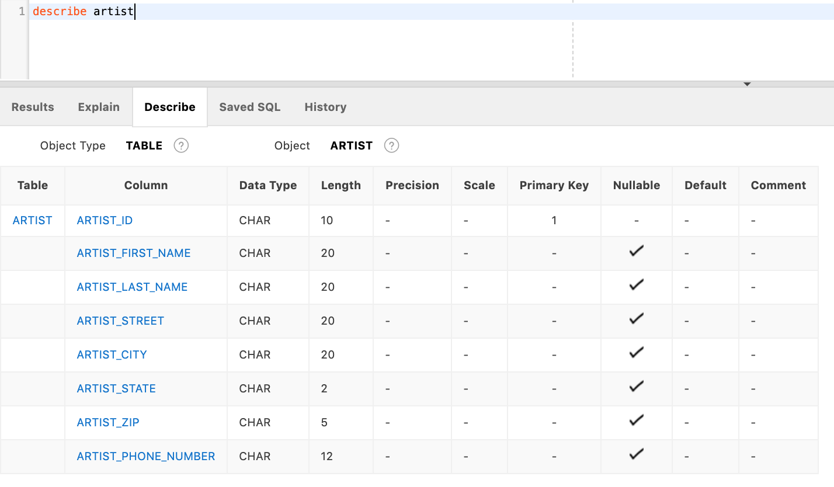

Table 1. ARTIST

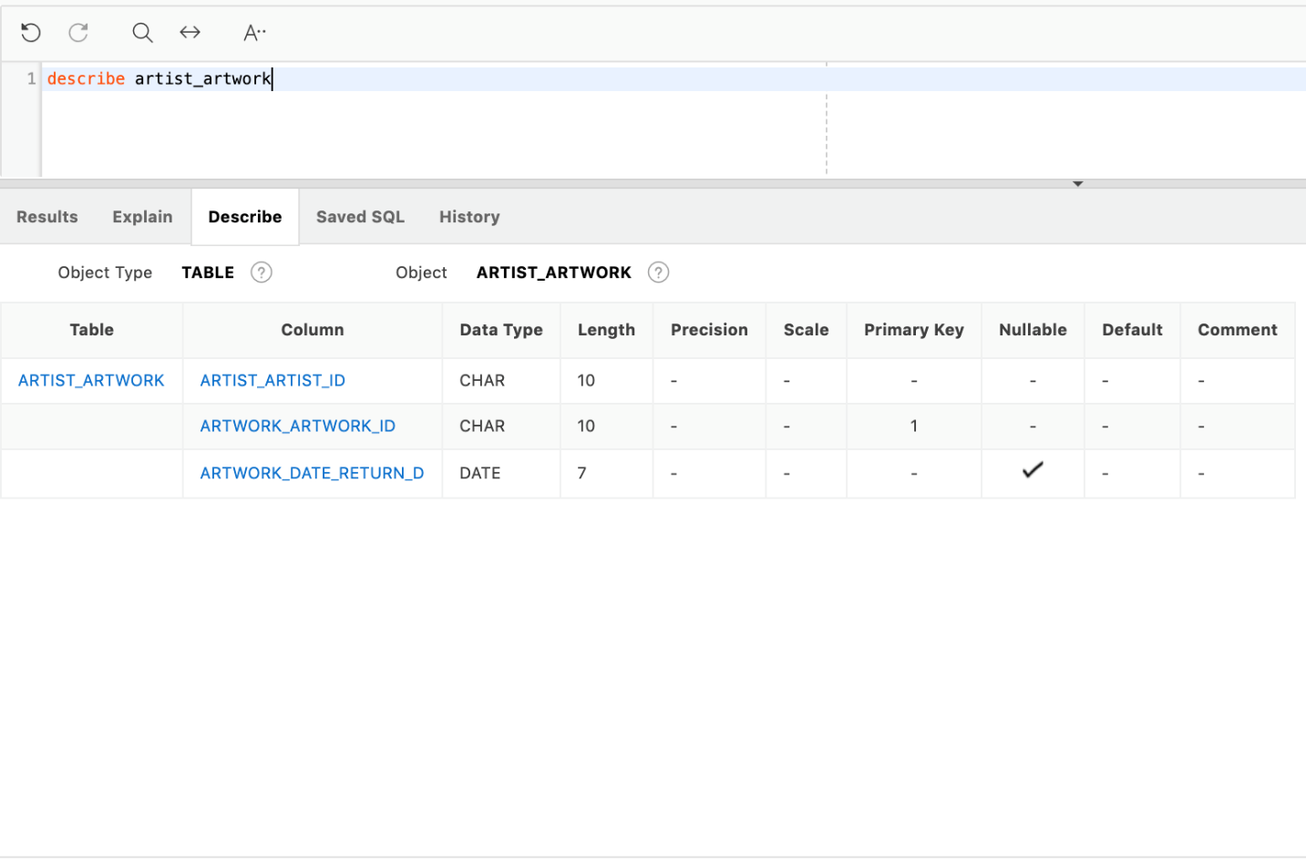

Table 2. ARTIST_ARTWORK

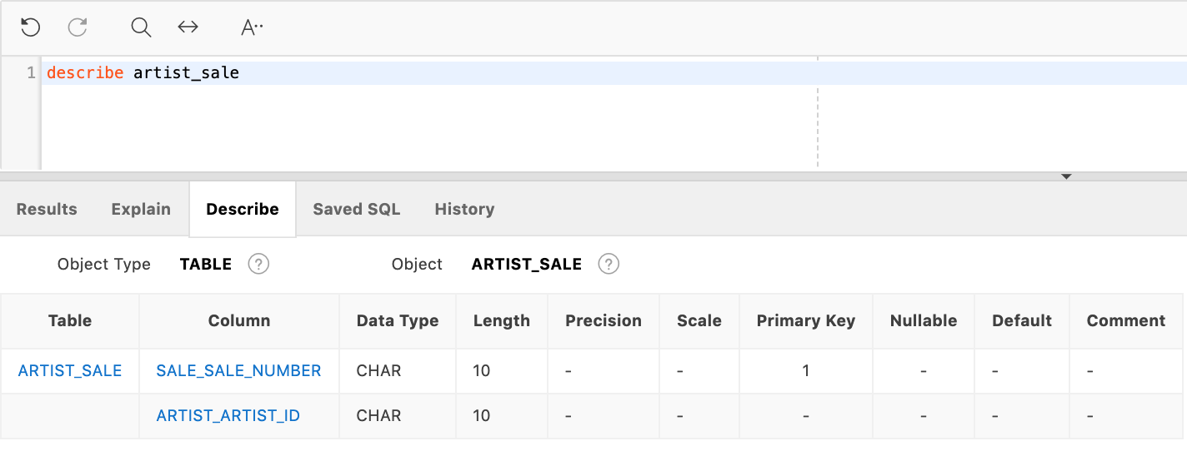

Table 3. ARTIST_SALE

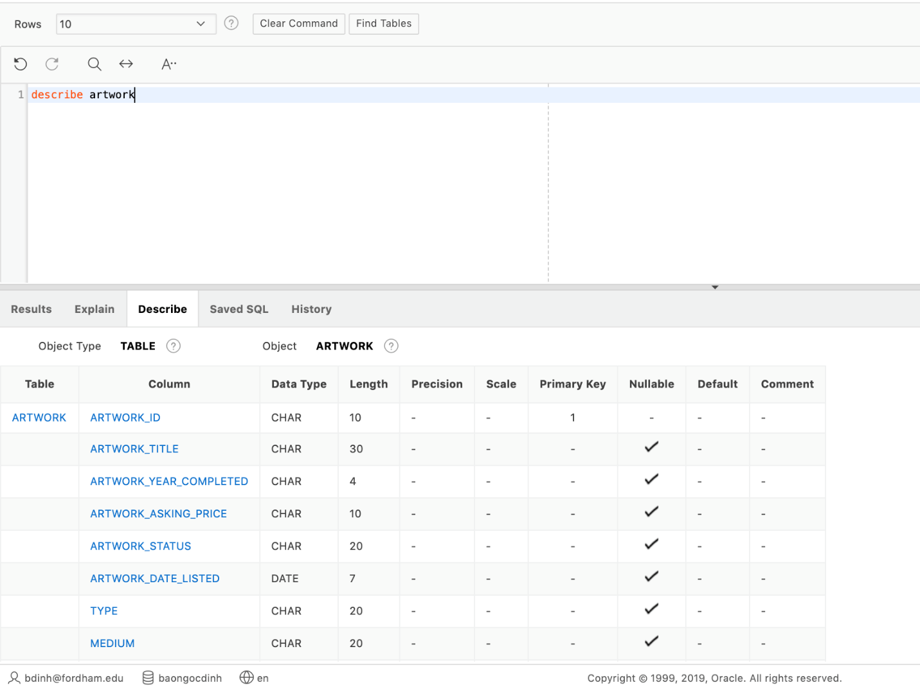

Table 4. ARTWORK

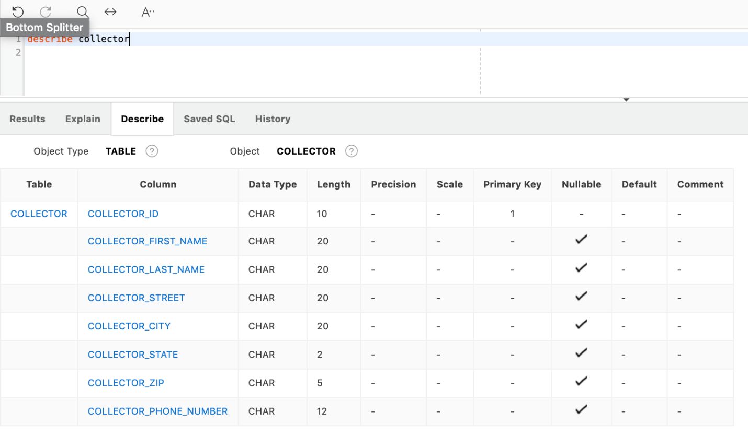

Table 5. COLLECTOR

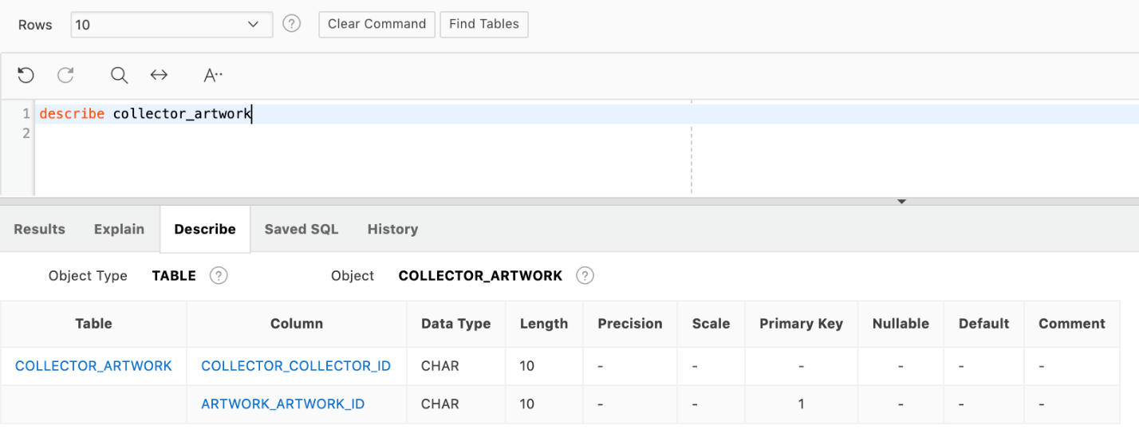

Table 6. COLLECTOR_ARTWORK

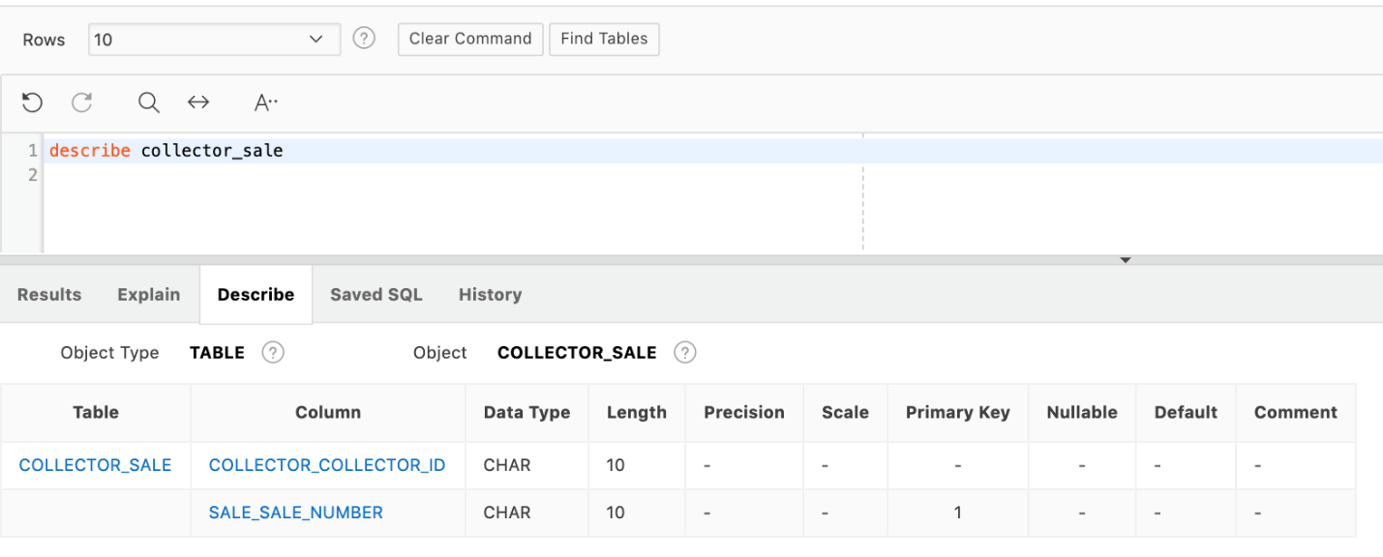

Table 7. COLLECTOR_SALE

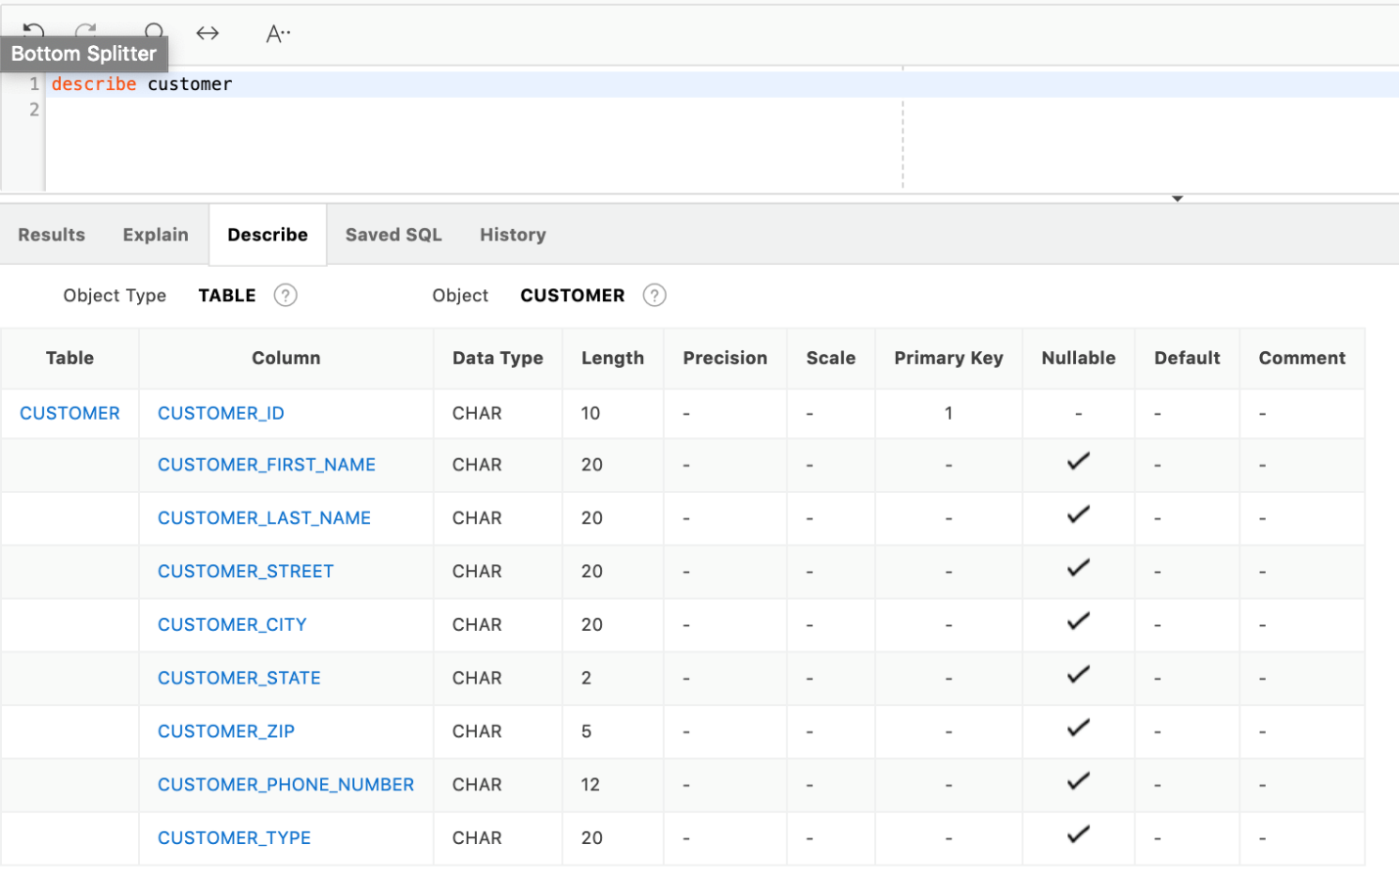

Table 8. CUSTOMER

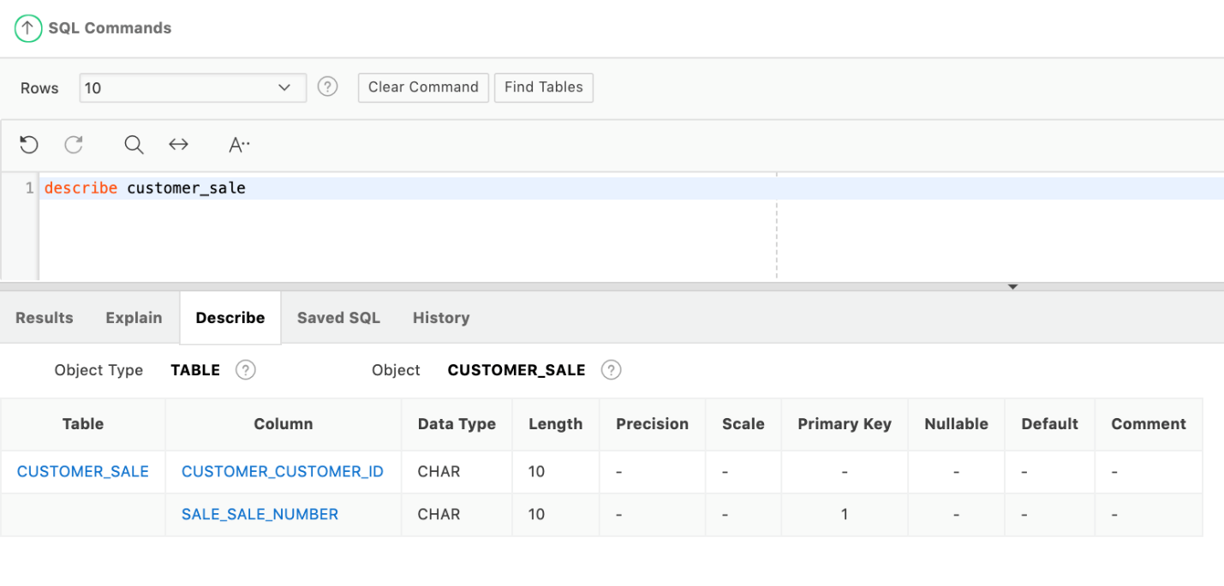

Table 9. CUSTOMER_SALE

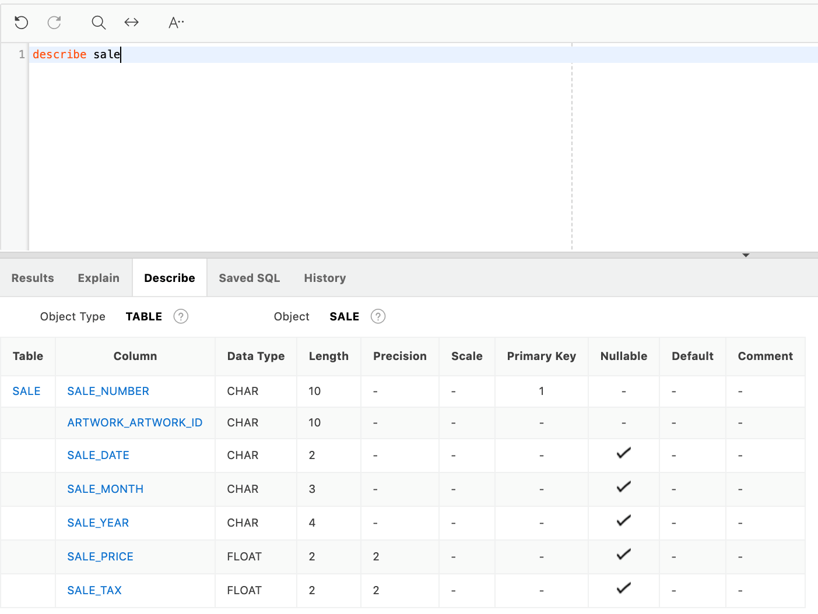

Table 10. SALE

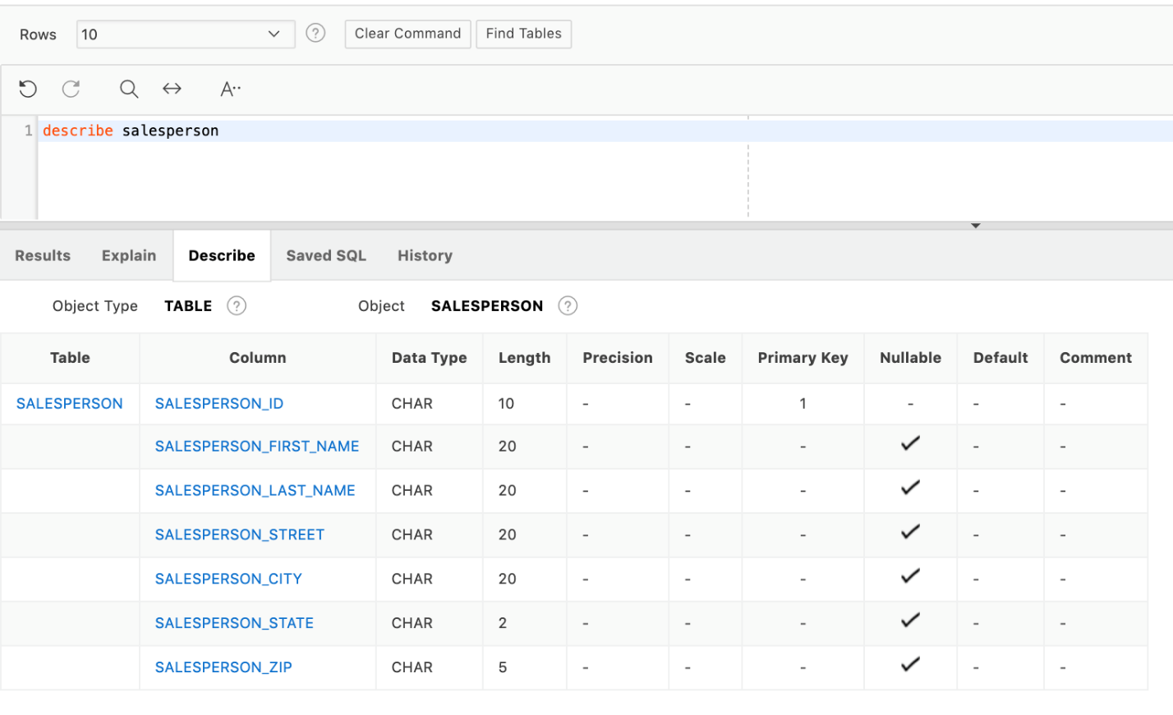

Table 11. SALESPERSON

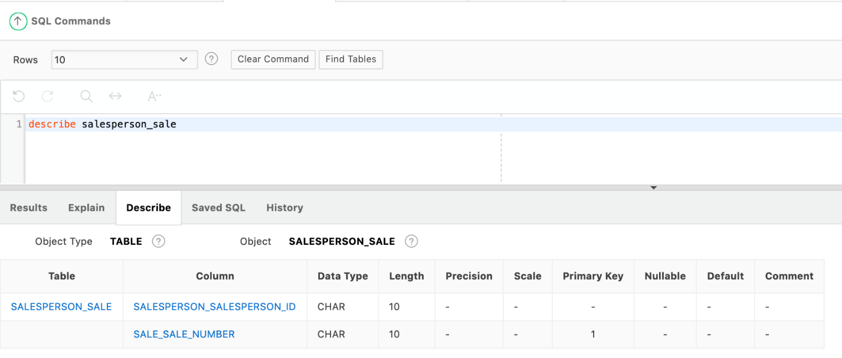

Table 12. SALEPERSON_SALE

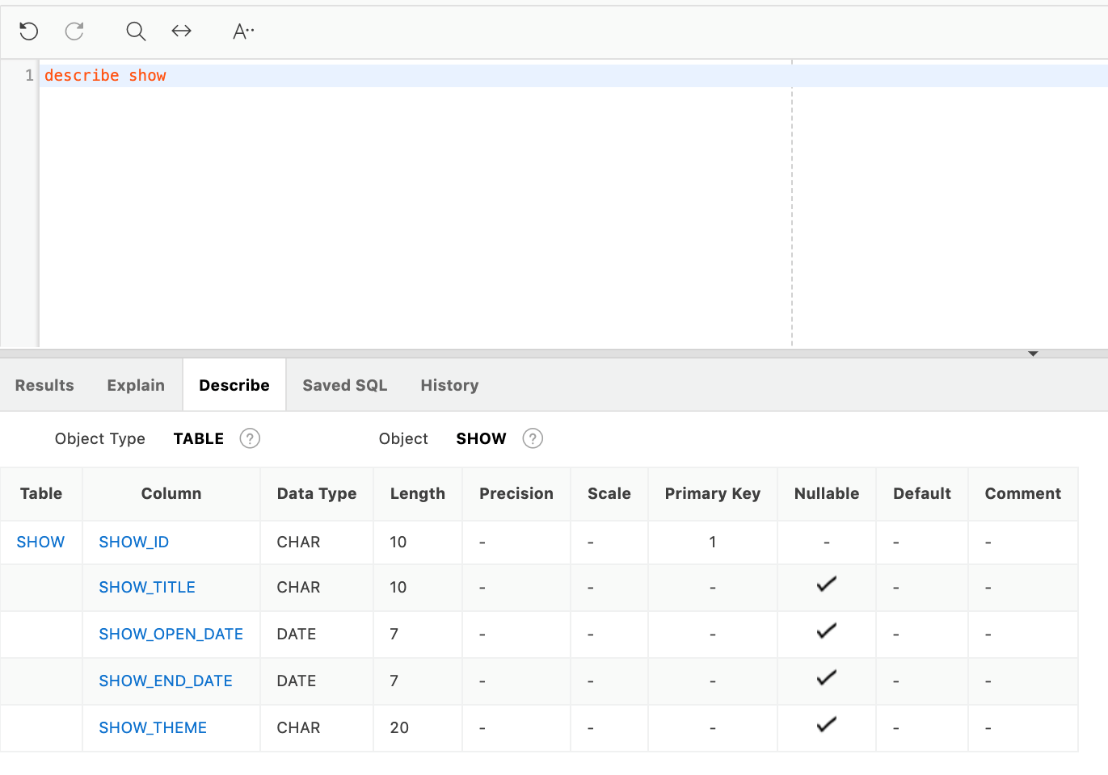

Table 13. SHOW

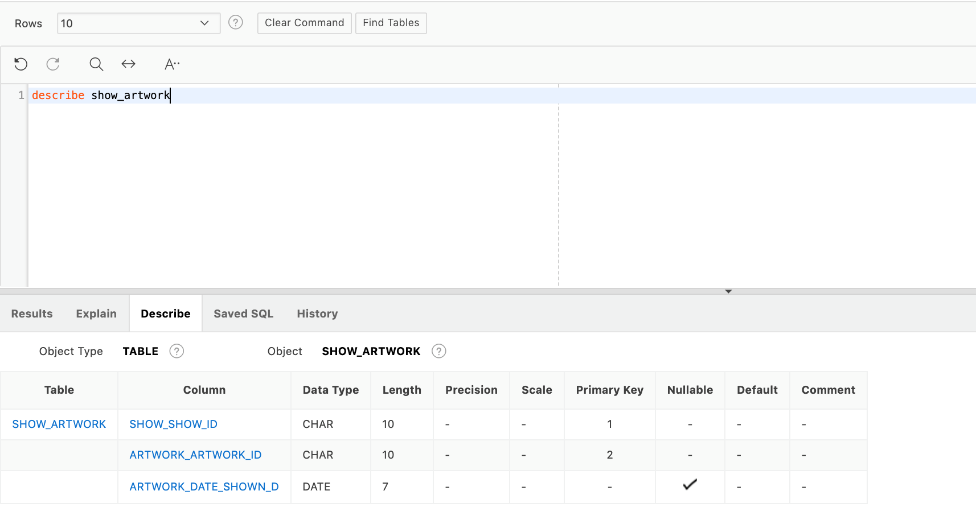

Table 14. SHOW_ARTWORK

**List of Tables**

|  |  |
| --- | --- |
|  | Name of Tables |
| 1 | ARTIST |
| 2 | ARTIST_ARTWORK |
| 3 | ARTIST_SALE |
| 4 | ARTWORK |
| 5 | COLLECTOR |
| 6 | COLLECTOR_ARTWORK |
| 7 | COLLECTOR_SALE |
| 8 | CUSTOMER |
| 9 | CUSTOMER_SALE |
| 10 | SALE |
| 11 | SALESPERSON |
| 12 | SALESPERSON_SALE |
| 13 | SHOW |
| 14 | SHOW_ARTWORK |

**Tables with Data for Art Gallery Tracking System**

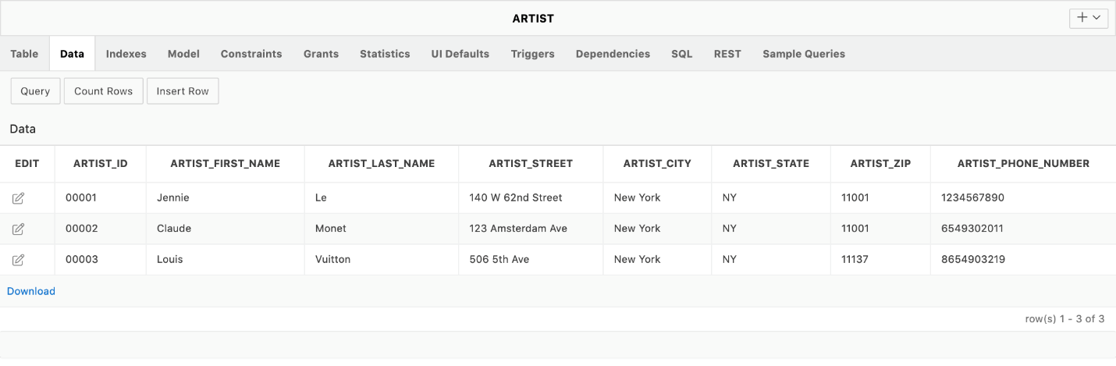

Table 1. ARTIST

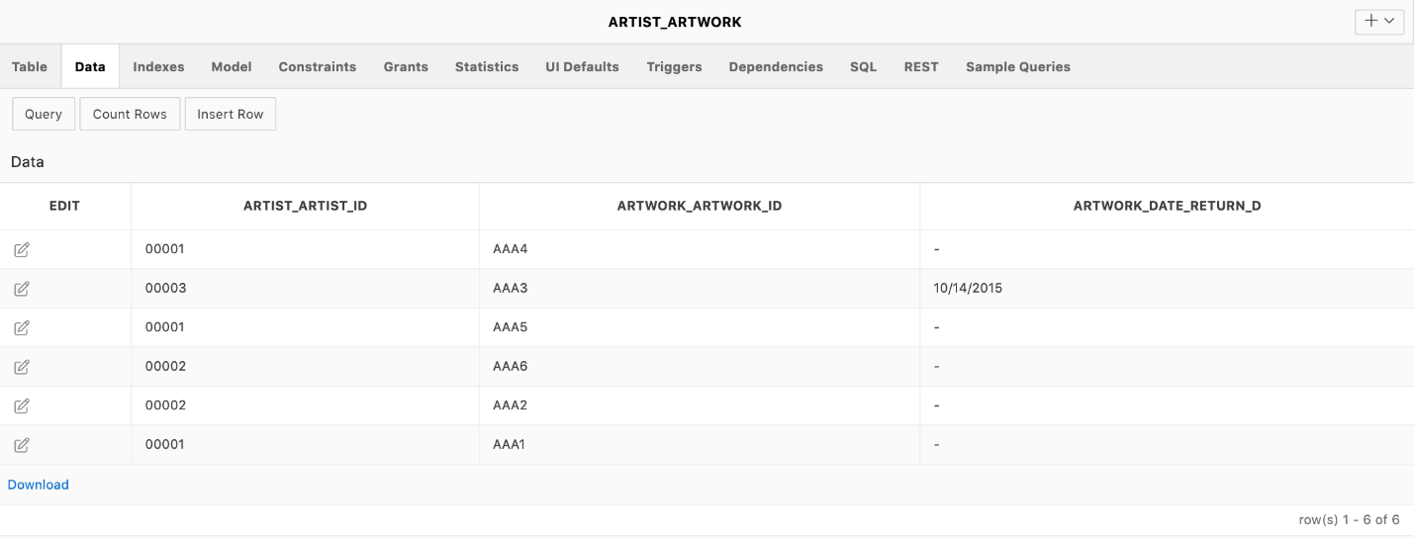

Table 2. ARTIST_ARTWORK

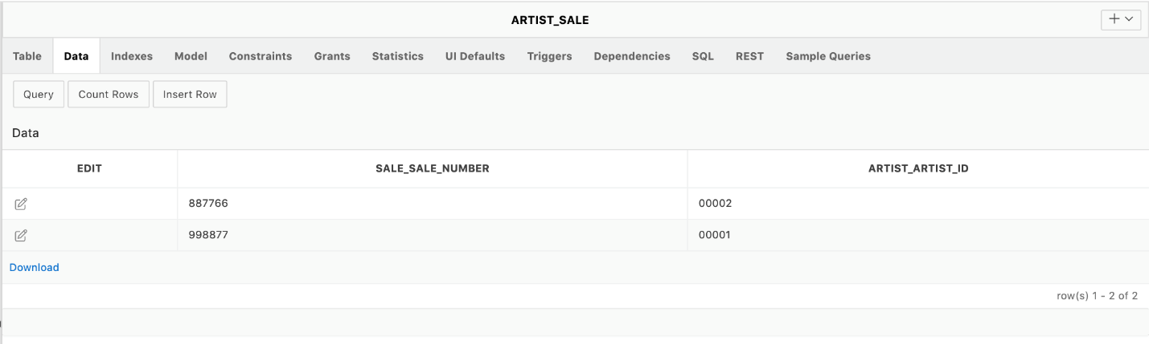

Table 3. ARTIST_SALE

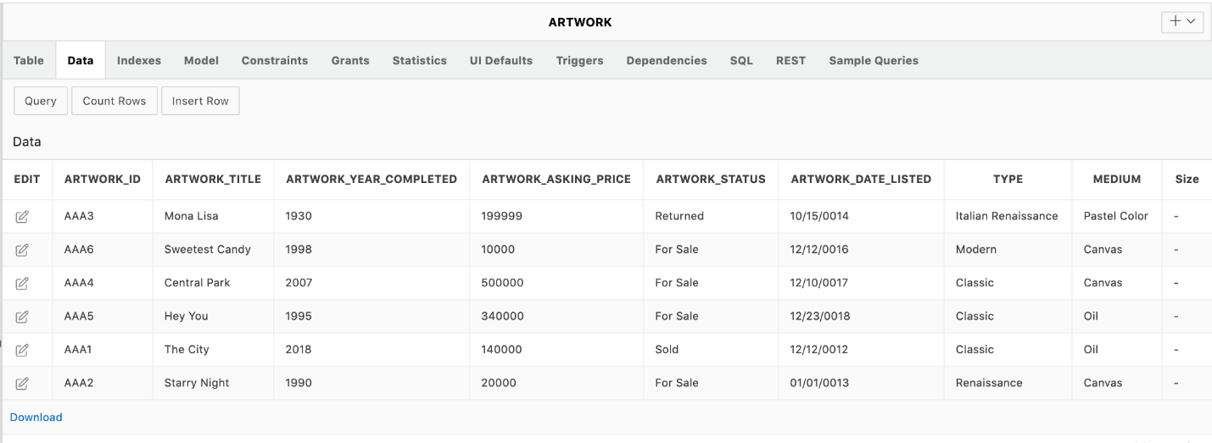

Table 4. ARTWORK

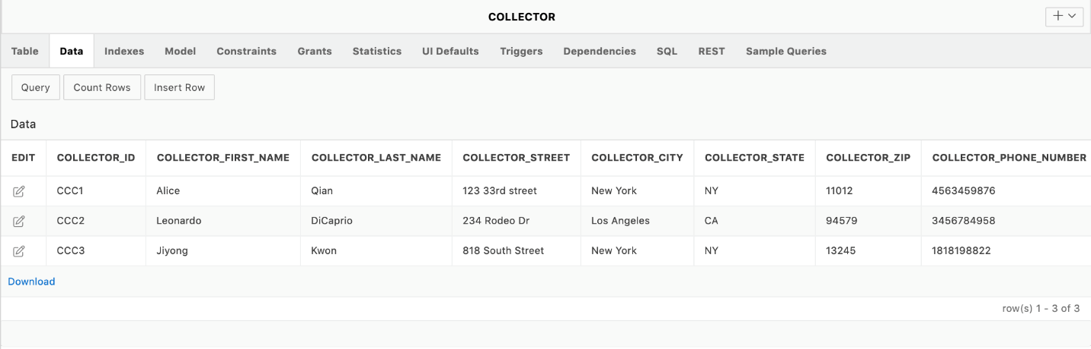

Table 5. COLLECTOR

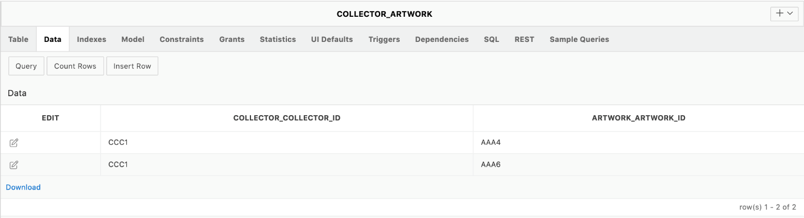

Table 6. COLLECTOR_ARTWORK

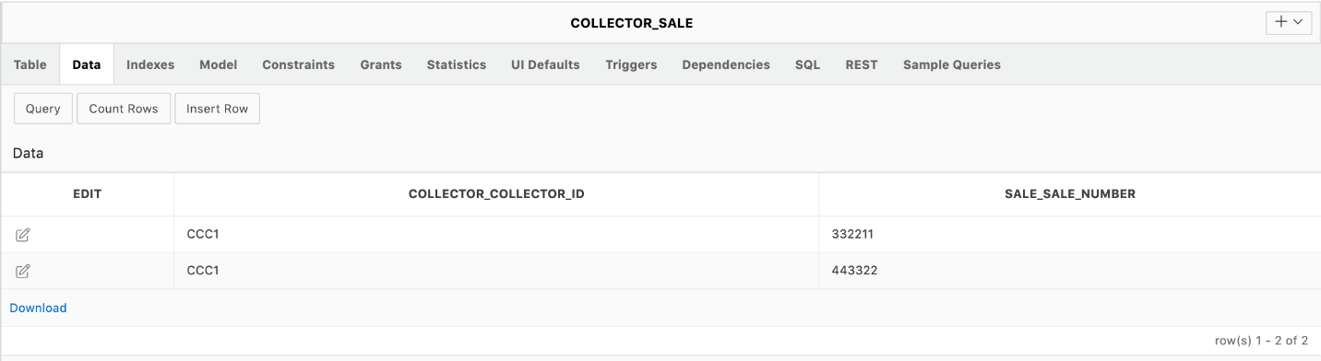

Table 7. COLLECTOR_SALE

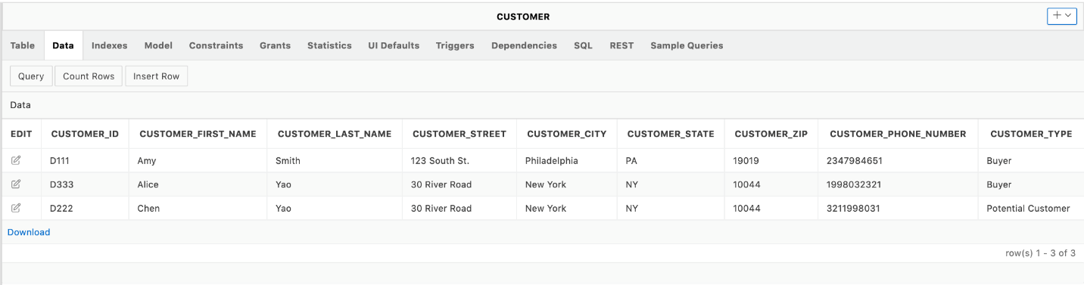

Table 8. CUSTOMER

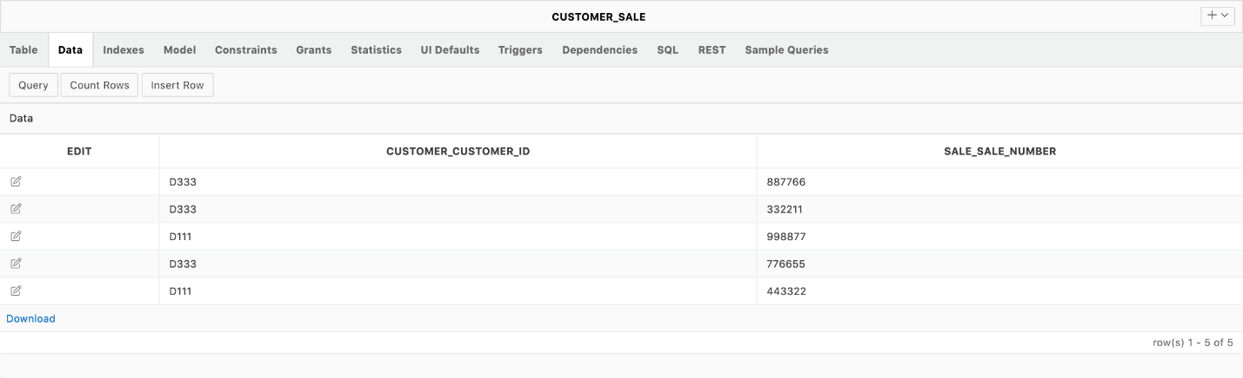

Table 9. CUSTOMER_SALE

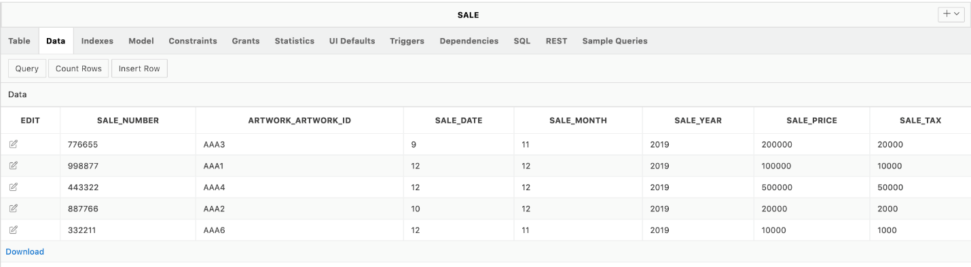

Table 10. SALE

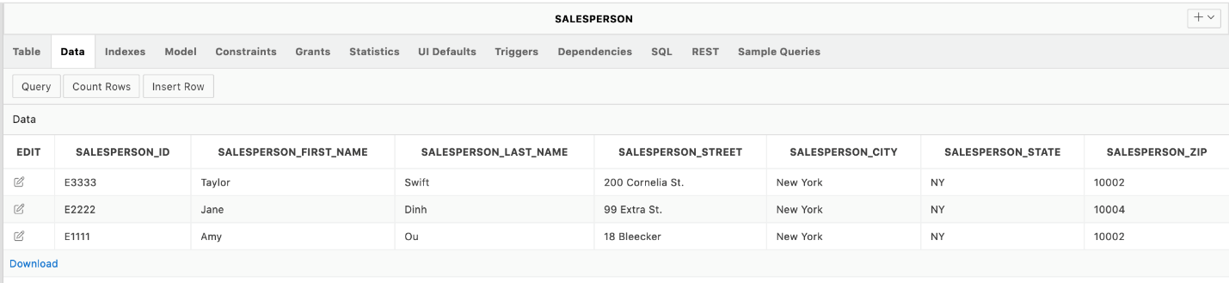

Table 11. SALESPERSON

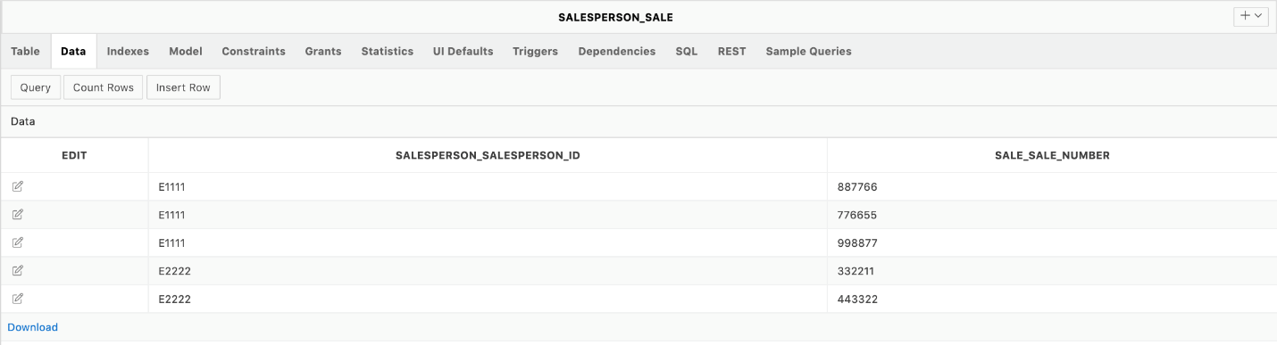

Table 12. SALEPERSON_SALE

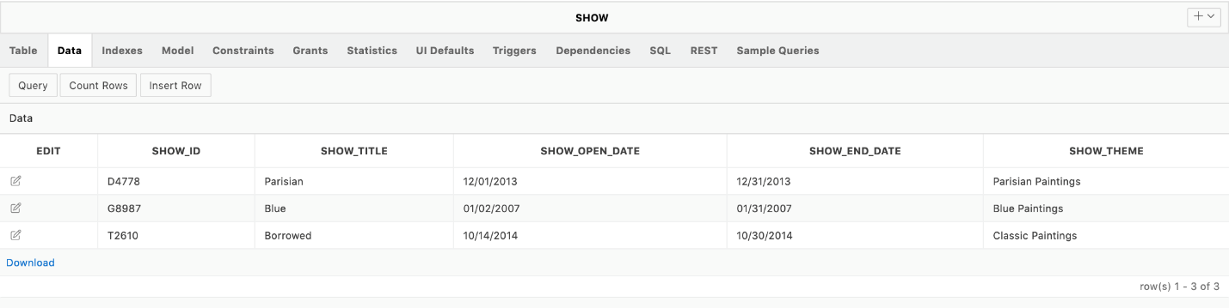

Table 13. SHOW

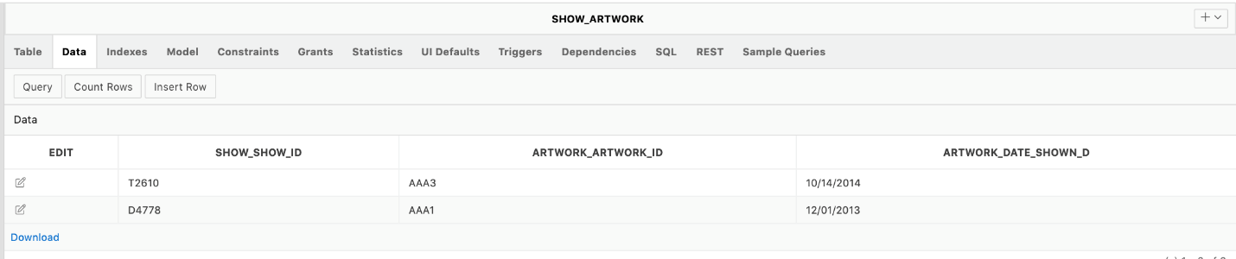

Table 14. SHOW_ARTWORK

**Art Gallery Tracking System Database SQL Command**

1. List the artwork that is created by an artist and currently owned by one of the collectors.

select ARTIST_FIRST_NAME, ARTIST_LAST_NAME, ARTWORK_TITLE, COLLECTOR_FIRST_NAME, COLLECTOR_LAST_NAME

from COLLECTOR, COLLECTOR_ARTWORK, ARTWORK, ARTIST_ARTWORK, ARTIST

where ARTIST.ARTIST_ID = ARTIST_ARTWORK.ARTIST_ARTIST_ID

and ARTIST_ARTWORK.ARTWORK_ARTWORK_ID = ARTWORK.ARTWORK_ID

and COLLECTOR_ARTWORK.ARTWORK_ARTWORK_ID = ARTWORK.ARTWORK_ID

and COLLECTOR_ARTWORK.COLLECTOR_COLLECTOR_ID = COLLECTOR.COLLECTOR_ID;

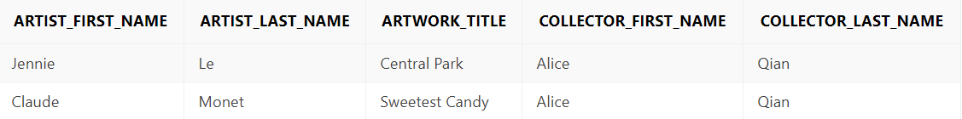

1. Present the sale records along with the artwork sold, salesperson in charge, buyer name and the sale price and tax. Ordered by sales price for your reference of business decision making.

select SALESPERSON_FIRST_NAME, SALE_PRICE, SALE_TAX, ARTWORK_TITLE,

CUSTOMER_FIRST_NAME, CUSTOMER_LAST_NAME

from ARTWORK, CUSTOMER_SALE, CUSTOMER, SALESPERSON, SALESPERSON_SALE, SALE

where SALE.SALE_NUMBER = SALESPERSON_SALE.SALE_SALE_NUMBER

and CUSTOMER_SALE.CUSTOMER_CUSTOMER_ID = CUSTOMER.CUSTOMER_ID

and CUSTOMER_SALE.SALE_SALE_NUMBER = SALE.SALE_NUMBER

and SALESPERSON_SALE.SALESPERSON_SALESPERSON_ID = SALESPERSON.SALESPERSON_ID

and SALE.ARTWORK_ARTWORK_ID = ARTWORK.ARTWORK_ID

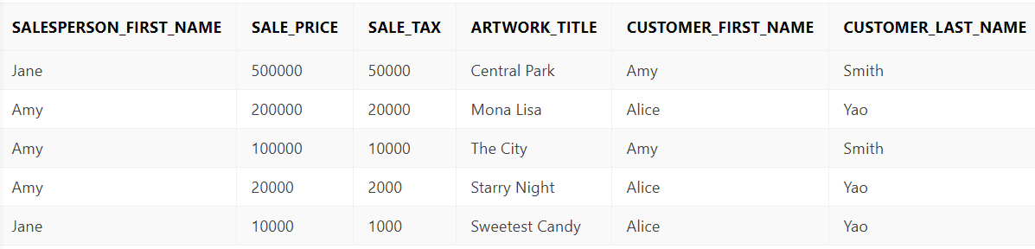order by SALE.SALE_PRICE DESC;

1. List all information about the titles, salesperson name, sale price and collector name of all artworks provided by a collector.

select ARTWORK_TITLE, SALESPERSON_FIRST_NAME, SALESPERSON_LAST_NAME, SALE_PRICE, COLLECTOR_FIRST_NAME, COLLECTOR_LAST_NAME

from ARTWORK, SALESPERSON, COLLECTOR, SALE, COLLECTOR_SALE, SALESPERSON_SALE, COLLECTOR_ARTWORK

where SALESPERSON.SALESPERSON_ID = SALESPERSON_SALE.SALESPERSON_SALESPERSON_ID

and SALE.SALE_NUMBER = SALESPERSON_SALE.SALE_SALE_NUMBER

and COLLECTOR.COLLECTOR_ID = COLLECTOR_SALE.COLLECTOR_COLLECTOR_ID

and SALE.SALE_NUMBER = COLLECTOR_SALE.SALE_SALE_NUMBER

and COLLECTOR.COLLECTOR_ID = COLLECTOR_ARTWORK.COLLECTOR_COLLECTOR_ID

and ARTWORK.ARTWORK_ID = COLLECTOR_ARTWORK.ARTWORK_ARTWORK_ID

and SALE.ARTWORK_ARTWORK_ID = ARTWORK.ARTWORK_ID;

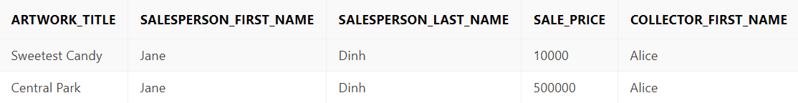

1. List artworks that are presented in the show and actually sold and display the artist name, artwork title, show title and customer name for the artworks.

select ARTIST_FIRST_NAME, ARTIST_LAST_NAME, ARTWORK_TITLE, SHOW_TITLE, CUSTOMER_FIRST_NAME, CUSTOMER_LAST_NAME

from CUSTOMER_SALE, SALE, SHOW_ARTWORK, ARTIST_ARTWORK, CUSTOMER, SHOW, ARTWORK, ARTIST

where ARTIST_ARTWORK.ARTWORK_ARTWORK_ID=ARTWORK.ARTWORK_ID

and ARTIST.ARTIST_ID=ARTIST_ARTWORK.ARTIST_ARTIST_ID

and SHOW.SHOW_ID=SHOW_ARTWORK.SHOW_SHOW_ID

and SHOW_ARTWORK.ARTWORK_ARTWORK_ID=ARTWORK.ARTWORK_ID

and CUSTOMER_SALE.CUSTOMER_CUSTOMER_ID=CUSTOMER.CUSTOMER_ID

and CUSTOMER_SALE.SALE_SALE_NUMBER=SALE.SALE_NUMBER

and SALE.ARTWORK_ARTWORK_ID=ARTWORK.ARTWORK_ID;

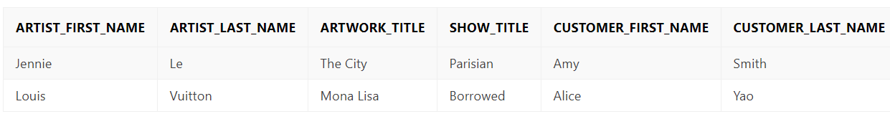

1. Find all the salesperson and their commission from each sale? (Sales Commission is 10% of Sales price)

select SALESPERSON_ID, SALESPERSON_FIRST_NAME, SALESPERSON_LAST_NAME, SALE_SALE_NUMBER,(SALE_PRICE*.1) as "Salesperson Commission"

from salesperson, sale, salesperson_sale

where salesperson_sale.SALESPERSON_SALESPERSON_ID=salesperson.SALESPERSON_ID and salesperson_sale.SALE_SALE_NUMBER=sale.sale_number;

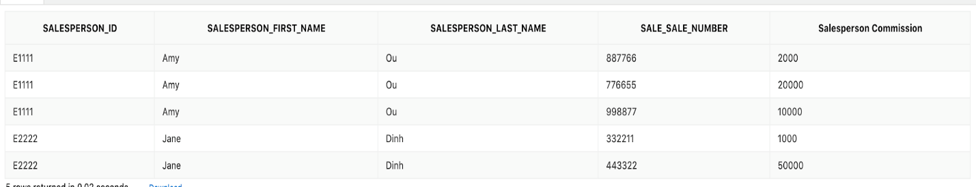

1. Find all information on the shows the museum has run, their open and end date, theme, artworks that were showcased and their type, medium and size:

select show_title, show_open_date, show_end_date, show_theme, artwork_title, "TYPE", medium, "Size"

from artwork, show_artwork, show

where SHOW_ID=SHOW_SHOW_ID

AND ARTWORK_ARTWORK_ID=ARTWORK_ID

order by show_open_date;



1. Find all the sales that came from collector, the date of sale, sale price and the amount the gallery remitted to the collector:

select sale_number, sale_date||'/'||sale_month||'/'||sale_year as "DATE OF SALE", sale_price, (sale_price*.7) as "AMOUNT REMITTED TO COLLECTOR"

from sale, collector_sale, collector

where COLLECTOR_COLLECTOR_ID=collector.collector_id

and SALE_SALE_NUMBER=sale.sale_number;



1. Find all the sales, date of sale, the salesperson in charge of the sales, sales price where the amount of the sale is bigger than $150,000:

select sale_number, sale_date||'/'||sale_month||'/'||sale_year AS date_of_sale, SALESPERSON_FIRST_NAME||' '||SALESPERSON_LAST_NAME as Salesperson_Name, sale_price

from sale, salesperson, salesperson_sale

where sale_price>=150000 and SALE_NUMBER=SALE_SALE_NUMBER

and SALESPERSON_SALESPERSON_ID=salesperson_id;



1. Find all the shows and artworks that were featured in the show where the artwork’s completion year is before 1910:

select show_title, SHOW_OPEN_DATE, SHOW_END_DATE, SHOW_THEME, ARTWORK_TITLE, ARTWORK_YEAR_COMPLETED

from show, artwork, show_artwork

where ARTWORK_YEAR_COMPLETED>1910 and show_id=SHOW_SHOW_ID

and artwork_id=ARTWORK_ARTWORK_ID;

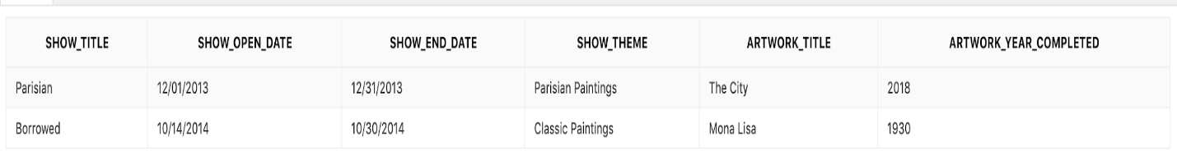

1. Find all the salesperson that has made a sale, how many sales they have made. Sort by descending count of sales:

select SALESPERSON_FIRST_NAME, SALESPERSON_LAST_NAME, count(*)

from salesperson, salesperson_sale

where salesperson_id=SALESPERSON_SALESPERSON_ID

group by SALESPERSON_FIRST_NAME, SALESPERSON_LAST_NAME

order by COUNT(*) DESC;

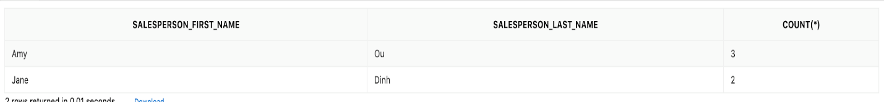

1. List an art work id and the sale price each time an artist id 00002 make a sale

select ARTWORK_ARTWORK_ID, SALE_PRICE

from SALE

where SALE_NUMBER in

(select SALE_SALE_NUMBER from ARTIST_SALE

where ARTIST_ARTIST_ID = '00002');

|  |  |
| --- | --- |
| **ARTWORK_ARTWORK_ID** | **SALE_PRICE** |
| AAA2 | 20000 |

1. List the show title, show theme, show open date, and the artwork ID in the show by combining show and show_artwork tables from left to right.

select SHOW_TITLE, SHOW_THEME, SHOW_OPEN_DATE, ARTWORK_ARTWORK_ID

from "SHOW" left outer join SHOW_ARTWORK

on SHOW_ID = SHOW_ARTWORK.SHOW_SHOW_ID;

|  |  |  |  |
| --- | --- | --- | --- |
| **SHOW_TITLE** | **SHOW_THEME** | **SHOW_OPEN_DATE** | **ARTWORK_ARTWORK_ID** |
| Parisian | Parisian Paintings | 12/01/2013 | AAA1 |
| Blue | Blue Paintings | 01/02/2007 | - |
| Borrowed | Classic Paintings | 10/14/2014 | AAA3 |

**Art Gallery Tracking System Database in APEX**

